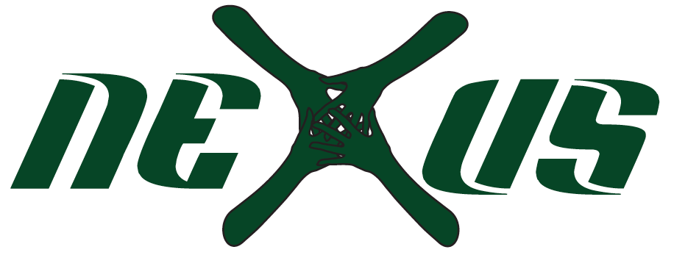

Player’s name: ________________________________ DOB: ____________ Grade: ______
Address: ___________________________________________________City/Zip:____________________
Primary Email: _____________________________________
Team interested in (Please circle): TRAVEL NON- TRAVEL EITHER
Previous Club experience: __________ Club name: ___________________________

Parent Permission, Medical & Liability Release

_____I authorize Nexus Athletic Club (“Nexus” or the “Club”) and those associated with the Club to administer general first aid treatment for any minor injuries that may occur during my daughter’s participation in Nexus activities, including, but not limited to, tryouts, practices, tournaments, clinics & open gyms. I authorize Nexus to provide general over-the-counter pain relief medication, including acetaminophen (e.g.,Tylenol), naproxen (e.g., Alieve), ibuprofen (e.g., Advil), antihistamine (e.g., Zyrtec) and antacid (e.g., Tums).

_____If the injury sustained is life threatening or in need of emergency treatment, I authorize Nexus or its representatives to summons any professional emergency personnel to attend, transport and treat my child. I understand that my medical insurance company or I are solely responsible for all bills and claims that may be filed as a result of the injury, including any hospitalization required as a result of the injury. I understand that there are risks and dangers inherent in participating in and/or receiving instructions about sporting activities during any sporting event, including those operated by Nexus. I understand that the risks include, but are not limited to potential strains, bruises, cuts, broken bone(s), head injuries, bodily injuries, and death from participation in and normal contact during volleyball events as well as unexpected contact(s) with other players, spectators, other participants, Nexus personnel, agents, representatives or contractors, walls, floors, equipment, or other items used during Nexus activities. My daughter is qualified, in good health and proper physical condition to participate in the Activities.

_____By signing and initialing this medical release and liability release form, I understand that I will not hold Nexus or its directors, employees, coaches, volunteers or other representatives responsible for any injury sustained to my child or for any other reason while my daughter is participating in Nexus activities. I further hold harmless Nexus, from all claims by me, or my family, estate, heirs, or assigns, arising out of or resulting from my child participating in and/or receiving instruction(s) in connection with Nexus activities. In circumstances where all or any portion of the provisions of this paragraph are finally determined to be unavailable, the aggregate liability of Nexus or its directors, employees, coaches, volunteers or other representatives for any claims, liabilities or expenses relating to my daughter’s participation (“Claims”) shall not exceed an amount which is proportional to the relative fault that their conduct bears to all other conduct giving rise to such Claims.

_____I grant permission for photographs and/or videos to be taken of my child. Photos and/or videos are taken on different occasions. Any photos and/or videos may be posted on our web site or social media page.

____________________________________ _____________________________________ _____
Print Name of Parent or Guardian Signature of Parent or Guardian Date

Emergency Contact Information:

Mother (print full name): _________________________________________________________
Primary Contact #: _______________________________
Father (print full name): __________________________________________________________
Primary Contact #: _______________________________
Other (print full name): __________________________________________________________
Relationship to Player: ______________________________________
Primary Contact #: _______________________________

